Shrinkage correlation: EURUSD and USDJPY
Method 08 / eight-major panel / delta = 0.2 and Ledoit-Wolf / Alpari D1 full available history

Study setup
Logical pair: EURUSD , USDJPY
Broker symbols: EURUSD_i , USDJPY_i
Snapshot: 2026-11-03_majors_alpari_D1
Timeframe: D1
Common eight-major panel window: 1999-01-06 to 2026-11-02 (UTC bar dates)
Panel matched return count n: 7127
Dropped unfinished last bar dated 2026-11-03 UTC after a tick-volume check against the prior complete day.
Fixed shrinkage: delta=0.2, mu=3.9170889e-05 (mean of diag(S))
Ledoit-Wolf estimated delta: 0.0042157642
Panel symbols: EURUSD, GBPUSD, AUDUSD, NZDUSD, USDJPY, USDCHF, USDCAD, EURGBP
Complete matched rows (Excel): EURUSD-USDJPY_Shrinkage_D1.xlsx
Complete matched rows (HTML table): EURUSD-USDJPY_Shrinkage_D1_data.html

Method carried forward
Shrinkage blends the sample covariance matrix S of matched daily log returns of close, ln(close_t / close_t-1), toward a simple target, then converts the shrunk covariance into correlations. Quotes are not inverted. This experiment builds one common calendar across all eight majors, forms S with the unbiased n-1 divisor, then reports two shrinkage specs: fixed delta = 0.2 with mu equal to the average sample variance (mu * I target), and sklearn Ledoit-Wolf with its estimated delta. Pair reports pull rho_ij from those panel matrices. Same-panel Pearson r is a side check only. Shrinkage improves conditioning; it is not a cause, not a lead, and not a trading signal.

Results
pearson_r | rho_02 | rho_LW | rho_02_minus_r | rho_LW_minus_r | delta_LW
-0.299566 | -0.235461 | -0.29819 | 0.064105 | 0.001375 | 0.00421576

Conclusion
Over the common 7127-day eight-major panel for EURUSD and USDJPY (broker quote directions unchanged), fixed-delta shrinkage correlation at delta=0.2 is -0.2355 (negative, weak linear link in this sample). Ledoit-Wolf rho is -0.2982 with estimated delta=0.004216. Same-panel Pearson r is -0.2996 (rho_02 minus r = 0.0641; rho_LW minus r = 0.0014). This does not establish cause, lead-lag, or a lasting trading rule.

Charts
Daily closes
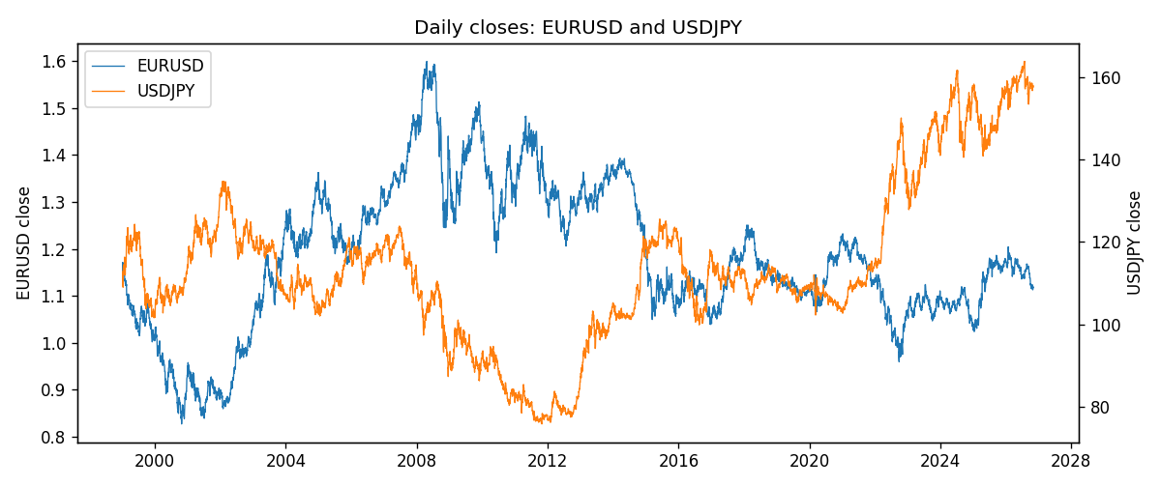
Daily log returns
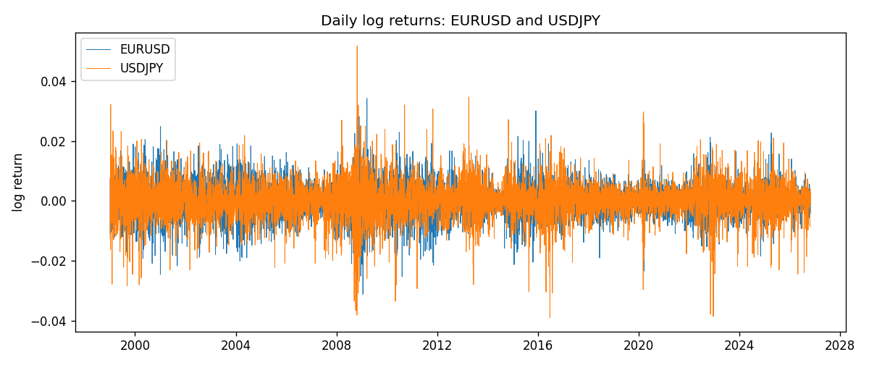
Log-return scatter
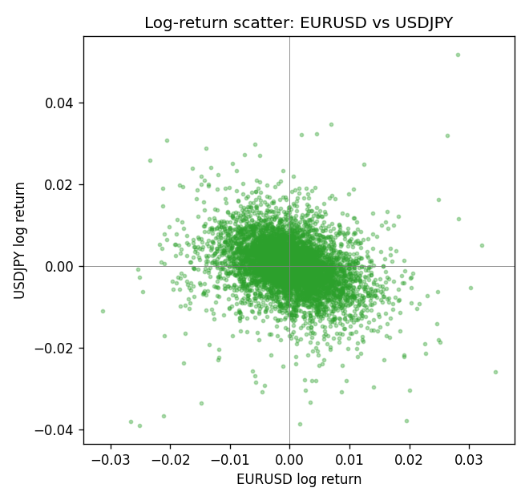

Data report
Every panel row for this pair slice is stored in the sibling Excel workbook named EURUSD-USDJPY_Shrinkage_D1.xlsx. Full-panel covariance and correlation matrices are saved once under outputs/ as CSV files. Embedding all rows as a Word table is impractical at this length; the Word file holds the column list, column summaries, and the first and last 15 matched rows.
Columns: time, EURUSD_open, EURUSD_high, EURUSD_low, EURUSD_close, EURUSD_tick_volume, EURUSD_spread, EURUSD_real_volume, EURUSD_log_return, USDJPY_open, USDJPY_high, USDJPY_low, USDJPY_close, USDJPY_tick_volume, USDJPY_spread, USDJPY_real_volume, USDJPY_log_return
Column summaries (panel rows)
column | count | mean | std | min | 25% | 50% | 75% | max
EURUSD_open | 7127 | 1.1819407 | 0.15065555 | 0.8272 | 1.086455 | 1.16615 | 1.294285 | 1.5995
EURUSD_high | 7127 | 1.1870746 | 0.15125674 | 0.8326 | 1.09055 | 1.17128 | 1.29974 | 1.6038
EURUSD_low | 7127 | 1.1769341 | 0.14996546 | 0.8227 | 1.082375 | 1.16257 | 1.288915 | 1.5865
EURUSD_close | 7127 | 1.1819858 | 0.15061943 | 0.8267 | 1.08652 | 1.16617 | 1.294345 | 1.5997
EURUSD_tick_volume | 7127 | 103994.86 | 174033.72 | 469 | 9542.5 | 53148 | 99923.5 | 1471626
EURUSD_spread | 7127 | 19.176652 | 16.472988 | 0 | 8 | 12 | 20 | 50
EURUSD_real_volume | 7127 | 4.0656436e+10 | 1.6756658e+11 | 0 | 0 | 0 | 0 | 3.6149665e+12
EURUSD_log_return | 7127 | -3.8e-07 | 0.00580028 | -0.03123819 | -0.00324243 | 8.31e-06 | 0.00325629 | 0.03433183
USDJPY_open | 7127 | 113.80058 | 19.291864 | 75.693 | 104.3005 | 110.961 | 120.7475 | 163.824
USDJPY_high | 7127 | 114.29785 | 19.353625 | 76.001 | 104.822 | 111.42 | 121.29 | 163.978
USDJPY_low | 7127 | 113.2782 | 19.219415 | 75.402 | 103.814 | 110.515 | 120.2 | 163.628
USDJPY_close | 7127 | 113.81424 | 19.307121 | 75.811 | 104.298 | 110.98 | 120.725 | 163.851
USDJPY_tick_volume | 7127 | 107141.8 | 179947.68 | 197 | 10056 | 53577 | 93233 | 1803508
USDJPY_spread | 7127 | 20.095973 | 17.5534 | 0 | 6 | 11 | 30 | 50
USDJPY_real_volume | 7127 | 3.5056645e+10 | 1.6155964e+11 | 0 | 0 | 0 | 0 | 3.8834203e+12
USDJPY_log_return | 7127 | 5.336e-05 | 0.00621278 | -0.03908203 | -0.00319557 | 0.00013026 | 0.00340928 | 0.05184024
First 15 panel rows (selected columns)
time | EURUSD_close | USDJPY_close | EURUSD_log_return | USDJPY_log_return
1999-01-06 | 1.1623 | 112.77 | -0.011547966 | 0.0075660159
1999-01-07 | 1.1712 | 111.33 | 0.0076280636 | -0.012851583
1999-01-08 | 1.1585 | 110.8 | -0.010902799 | -0.0047719894
1999-01-11 | 1.1503 | 109.02 | -0.007103287 | -0.016195423
1999-01-12 | 1.1555 | 112.6 | 0.0045103728 | 0.032310364
1999-01-13 | 1.1681 | 113.52 | 0.010845346 | 0.0081373171
1999-01-14 | 1.1681 | 113.52 | 0 | 0
1999-01-15 | 1.1563 | 114.15 | -0.010153245 | 0.0055343401
1999-01-18 | 1.1605 | 114.16 | 0.0036256946 | 8.7600193e-05
1999-01-19 | 1.1603 | 113.52 | -0.00017235436 | -0.0056219403
1999-01-20 | 1.1566 | 112.91 | -0.0031939256 | -0.0053879917
1999-01-21 | 1.1601 | 113.87 | 0.0030215416 | 0.0084664056
1999-01-22 | 1.1587 | 114.56 | -0.0012075213 | 0.0060412564
1999-01-25 | 1.1552 | 113.72 | -0.0030251979 | -0.0073594164
1999-01-26 | 1.1562 | 113.86 | 0.00086527651 | 0.0012303367
Last 15 panel rows (selected columns)
time | EURUSD_close | USDJPY_close | EURUSD_log_return | USDJPY_log_return
2026-10-13 | 1.11965 | 158.305 | 0.0037402957 | -0.0018932826
2026-10-14 | 1.11545 | 158.317 | -0.0037582255 | 7.5800166e-05
2026-10-15 | 1.12172 | 158.024 | 0.0056053107 | -0.0018524319
2026-10-16 | 1.12371 | 157.964 | 0.0017724895 | -0.00037976126
2026-10-19 | 1.12086 | 158.517 | -0.0025394633 | 0.0034946841
2026-10-20 | 1.12354 | 158.16 | 0.0023881672 | -0.0022546642
2026-10-21 | 1.12318 | 158.108 | -0.00032046717 | -0.00032883504
2026-10-22 | 1.12139 | 156.755 | -0.0015949606 | -0.0085942669
2026-10-23 | 1.11989 | 156.81 | -0.001338521 | 0.00035080446
2026-10-26 | 1.11735 | 157.458 | -0.0022706559 | 0.0041238746
2026-10-27 | 1.11272 | 157.894 | -0.004152342 | 0.0027651658
2026-10-28 | 1.1152 | 157.743 | 0.0022262927 | -0.00095679538
2026-10-29 | 1.11772 | 157.683 | 0.0022571351 | -0.00038043789
2026-10-30 | 1.11644 | 157.516 | -0.0011458446 | -0.0010596481
2026-11-02 | 1.11881 | 157.933 | 0.002120569 | 0.0026438521

